1-Phrase

🧩 What is a Phrase in Linguistics?
# Source: Chatgpt (GPT-4-turbo) at [7/22/2025]
A phrase is a group of words that works together as a single part of speech (like a noun, verb, or adjective) but does not contain both a subject and a finite verb—so it's not a complete sentence.

📘 Definition:
# Source: Chatgpt (GPT-4-turbo) at [7/22/2025]
A phrase is a group of related words that functions as a single grammatical unit within a sentence.

🧠 Key Characteristics:
# Source: Chatgpt (GPT-4-turbo) at [7/22/2025]
- A phrase acts as one part of speech.
- It does not express a complete thought on its own.
- It cannot stand alone as a sentence.
- It may contain other smaller phrases (called constituents).

🔍 Types of Phrases with Examples:
# Source: Chatgpt (GPT-4-turbo) at [7/22/2025]
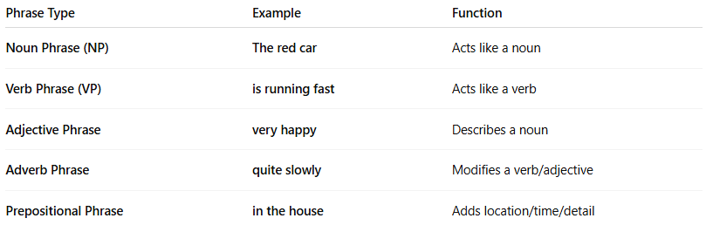
Phrase Type | Example | Function
Noun Phrase (NP) | The red car | Acts like a noun
Verb Phrase (VP) | is running fast | Acts like a verb
Adjective Phrase | very happy | Describes a noun
Adverb Phrase | quite slowly | Modifies a verb/adjective
Prepositional Phrase | in the house | Adds location/time/detail

🧾 Example in a Sentence:
# Source: Chatgpt (GPT-4-turbo) at [7/22/2025]
"The red car is moving quickly down the street."
- The red car → Noun Phrase (subject)
- is moving quickly down the street → Verb Phrase (predicate)
- quickly → Adverb (within the VP)
- down the street → Prepositional Phrase

✅ Summary:
# Source: Chatgpt (GPT-4-turbo) at [7/22/2025]
A phrase is a group of words that work together as one part of speech, but don’t form a complete sentence by themselves.

2-Clause

📚 What is a Clause in Grammar?
# Source: Chatgpt (GPT-4-turbo) at [7/22/2025]
A clause is a group of words that contains a subject and a predicate (verb). Some clauses can stand alone as sentences, while others depend on other clauses to make sense.

📘 Definition:
# Source: Chatgpt (GPT-4-turbo) at [7/22/2025]
A clause is a grammatical unit made up of a subject and a verb (predicate). It may or may not form a complete sentence.

🔍 Two Main Types of Clauses:
# Source: Chatgpt (GPT-4-turbo) at [7/22/2025]
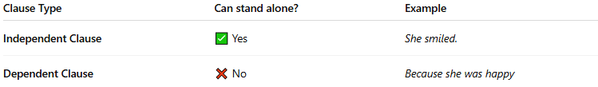

Clause Type | Can stand alone? | Example
Independent Clause | ✅ Yes | She smiled.
Dependent Clause | ❌ No | Because she was happy

🧠 Examples:

✅ Independent Clause
# Source: Chatgpt (GPT-4-turbo) at [7/22/2025]
A complete idea; can be a sentence by itself.
- I went home.
- The dog barked.
- It is raining.

❌ Dependent Clause (a.k.a. subordinate clause)
# Source: Chatgpt (GPT-4-turbo) at [7/22/2025]
An incomplete thought; needs an independent clause.
- When I arrived home
- Although it was late
- Because I was tired
These need something else to complete the meaning:
- When I arrived home, I took a nap.
- Although it was late, we kept working.

🧩 Special Types of Dependent Clauses:
# Source: Chatgpt (GPT-4-turbo) at [7/22/2025]
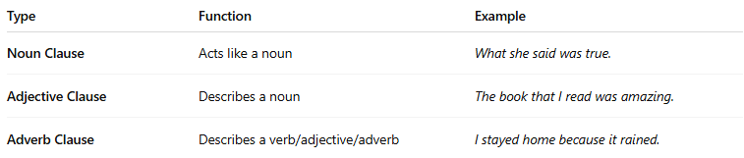

Type | Function | Example
Noun Clause | Acts like a noun | What she said was true.
Adjective Clause | Describes a noun | The book that I read was amazing.
Adverb Clause | Describes a verb/adjective/adverb | I stayed home because it rained.

✅ Summary:
# Source: Chatgpt (GPT-4-turbo) at [7/22/2025]
A clause is a group of words with a subject and verb.
- If it can stand alone, it’s an independent clause.
- If it depends on another clause, it’s a dependent clause.

3-Constituent

🧩 What is a Constituent in Linguistics?
# Source: Chatgpt (GPT-4-turbo) at [7/22/2025]
In linguistics, a constituent is a group of words that function as a single unit within a sentence's structure. Constituents can be individual words or larger phrases, like noun phrases, verb phrases, etc.

📘 Definition:
# Source: Chatgpt (GPT-4-turbo) at [7/22/2025]
A constituent is a syntactic unit—a word or group of words—that functions as a single part of a sentence’s structure.

🔍 Example Sentence:
# Source: Chatgpt (GPT-4-turbo) at [7/22/2025]
"The small cat sat on the mat."
This sentence contains several constituents:
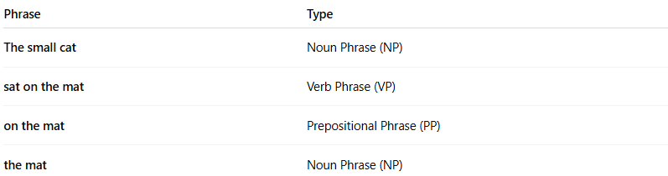
Phrase | Type
The small cat | Noun Phrase (NP)
sat on the mat | Verb Phrase (VP)
on the mat | Prepositional Phrase (PP)
the mat | Noun Phrase (NP)
Each of these groups acts like a unit in the sentence structure.

🧠 Why Constituents Matter:
# Source: Chatgpt (GPT-4-turbo) at [7/22/2025]
- They show how sentences are organized.
- Help identify parts of speech and phrases.
- Useful in syntax trees, grammar analysis, and language learning.

✅ Tests for Constituents:
# Source: Chatgpt (GPT-4-turbo) at [7/22/2025]
Linguists use certain tests to check if a group of words is a constituent:
- Substitution Test
Replace the group with a pronoun or word.
→ "The small cat" → "It"
- Movement Test
Move the phrase to a different place.
→ "On the mat, the small cat sat."
- Question Test
Form a question where the group is the answer.
→ Where did the cat sit? → "On the mat."

Constituent vs Phrase
# Source: Chatgpt (GPT-4-turbo) at [7/29/2025]
Both constituents and phrases are essential parts of sentence structure in syntax, but they are not identical. Here's a clear breakdown:

🔹 1. What is a Constituent?

✅ Definition:
# Source: Chatgpt (GPT-4-turbo) at [7/29/2025]
A constituent is any word or group of words that functions as a single unit within a larger syntactic structure (such as a sentence or clause).
Think of a constituent as a “building block” of a sentence.

🔍 Types of Constituents:
# Source: Chatgpt (GPT-4-turbo) at [7/29/2025]
- Words: She left.
- Phrases: [The old man] walked slowly.
- Clauses: [Because he was tired], he slept.

✅ A constituent can be:
# Source: Chatgpt (GPT-4-turbo) at [7/29/2025]
- A single word (e.g., dogs)
- A phrase (e.g., the brown dogs)
- Even a clause (e.g., that she left early)

🧪 Constituency Tests (used to identify constituents):
# Source: Chatgpt (GPT-4-turbo) at [7/29/2025]
- Substitution Test: Replace with a pronoun or phrase
→ The tall man walked = He walked ✅
- Movement Test: Move the group to another position
→ In the park, the kids played. ✅
- Question/Answer Test:
Q: Who walked the dog?
A: The girl with the ponytail. ✅

🔸 2. What is a Phrase?

✅ Definition:
# Source: Chatgpt (GPT-4-turbo) at [7/29/2025]
A phrase is a type of constituent — a group of words that work together as a unit and are centered around a head word (like a noun, verb, etc.).
All phrases are constituents, but not all constituents are phrases.

🔍 Common Types of Phrases:
# Source: Chatgpt (GPT-4-turbo) at [7/29/2025]
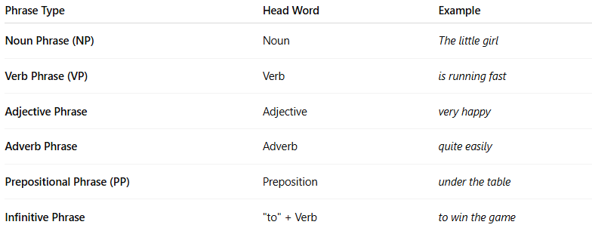
Phrase Type | Head Word | Example
Noun Phrase (NP) | Noun | The little girl
Verb Phrase (VP) | Verb | is running fast
Adjective Phrase | Adjective | very happy
Adverb Phrase | Adverb | quite easily
Prepositional Phrase (PP) | Preposition | under the table
Infinitive Phrase | "to" + Verb | to win the game

🧩 Key Differences
# Source: Chatgpt (GPT-4-turbo) at [7/29/2025]
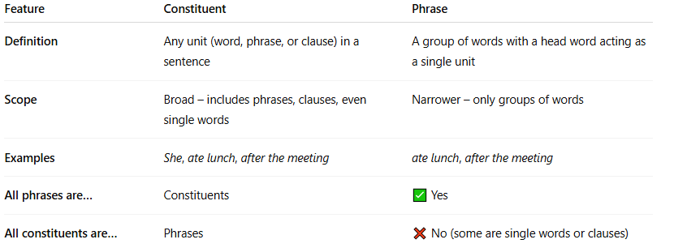
Feature | Constituent | Phrase
Definition | Any unit (word, phrase, or clause) in a sentence | A group of words with a head word acting as a single unit
Scope | Broad – includes phrases, clauses, even single words | Narrower – only groups of words
Examples | She, ate lunch, after the meeting | ate lunch, after the meeting
All phrases are… | Constituents | ✅ Yes
All constituents are… | Phrases | ❌ No (some are single words or clauses)

🧠 Summary:
# Source: Chatgpt (GPT-4-turbo) at [7/29/2025]
- ✅ Constituent = Any part of a sentence that acts as a unit (word, phrase, or clause)
- ✅ Phrase = A special kind of constituent with a head word

✅ Summary:
# Source: Chatgpt (GPT-4-turbo) at [7/22/2025]
A constituent is a word or group of words that function as a unit in a sentence’s grammar. They help us understand sentence structure, like phrases and clauses.

4-Complete Sentence

✅ What is a Complete Sentence?
# Source: Chatgpt (GPT-4-turbo) at [7/22/2025]
A complete sentence is a group of words that:
- Expresses a complete thought
- Has a subject (who or what the sentence is about)
- Has a predicate (what the subject is or does, including a verb)
- Begins with a capital letter and ends with correct punctuation (., ?, or !)

📘 Definition:
# Source: Chatgpt (GPT-4-turbo) at [7/22/2025]
A complete sentence is a grammatical unit that contains at least one independent clause—a subject and a verb, and it expresses a complete idea.

🧠 Components of a Complete Sentence:
# Source: Chatgpt (GPT-4-turbo) at [7/22/2025]
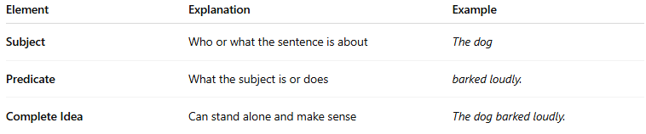

Element | Explanation | Example
Subject | Who or what the sentence is about | The dog
Predicate | What the subject is or does | barked loudly.
Complete Idea | Can stand alone and make sense | The dog barked loudly.

🧾 Examples:
# Source: Chatgpt (GPT-4-turbo) at [7/22/2025]
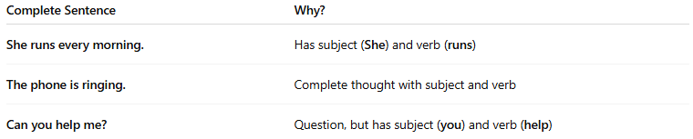
Complete Sentence | Why?
She runs every morning. | Has subject (She) and verb (runs)
The phone is ringing. | Complete thought with subject and verb
Can you help me? | Question, but has subject (you) and verb (help)

❌ Incomplete (Fragment) Examples:
# Source: Chatgpt (GPT-4-turbo) at [7/22/2025]

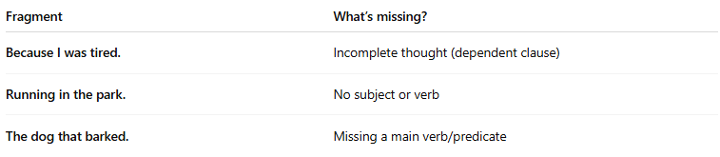
Fragment | What’s missing?
Because I was tired. | Incomplete thought (dependent clause)
Running in the park. | No subject or verb
The dog that barked. | Missing a main verb/predicate

✅ Summary:
# Source: Chatgpt (GPT-4-turbo) at [7/22/2025]
A complete sentence = Subject + Predicate (verb) + Complete Thought

